# **Customer Behaviour analysis for Barnes and Noble**

The dataset records customers’ purchases at two competitors: Amazon and Barnes and noble (BN) in 2007. Some customer demographics such as Id, income, education, age, country, region, race, household size (HHSZ) are captured along with books purchase details like book name, price, quantity, store (Amazon/BN).

Suppose you are working for Barnes and noble (making it a more challenging and interesting for our analytics) and would like to understand the factors that affect customers purchasing behaviour at BN. You want to figure out why some customers purchase a lot of books (e.g. >10 within 2007) while some are making just few purchases. What consumer characteristics drive the difference? And why certain customers prefer your competitor (say Amazon)? How can you attract them away?

>>> Ran Poisson regression model and Negative Binomial Regression model on above data in Base SAS.

Model results:

**Poisson regression results imply that the purchasing habit of customer at Barnes and Noble is affected by following customer characteristics-**

* Income
* Education
* Age
* Household size
* No. of child

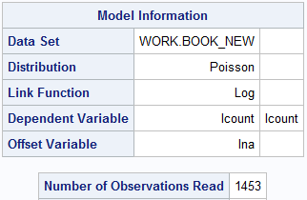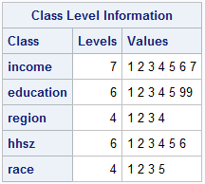

As shown below, income=5 is significant. Hence income is significant characteristic in determining the purchase.

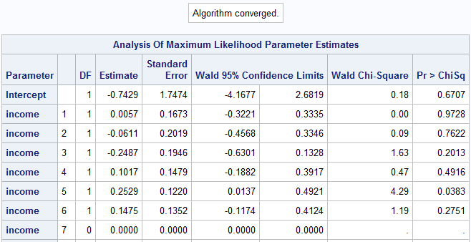

Here, education=2 and age are significant. Hence education and age are significant characteristics in determining the purchase.

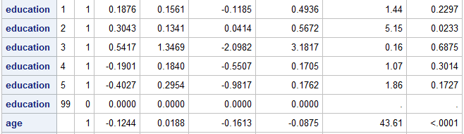

Country and region are not significant. hhsz=1 is significant variable. Hence household size significantly affects the purchasing habit of customer.

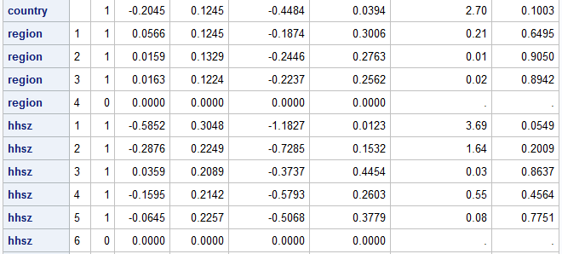

Child is significant, and race is not significant. Hence child is significant customer characteristic.

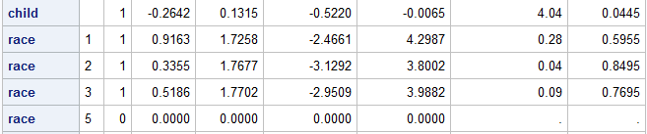

**Further analysis on BN and amazon purchases-**

As seen from the results, age, region, and country are the main characteristics that affect customers preference between Amazon and BN (10% level of significance). As predicted by odds ratio, impact of age is 1.8%; impact of region is 39.2%; and impact of country is 11.6% for making the decision between Amazon and BN for each customer.

